**Figure A1. Participant Flow Diagram for Analytic Samples**

The diagram illustrates the derivation of the analytic samples from the original longitudinal cohort.

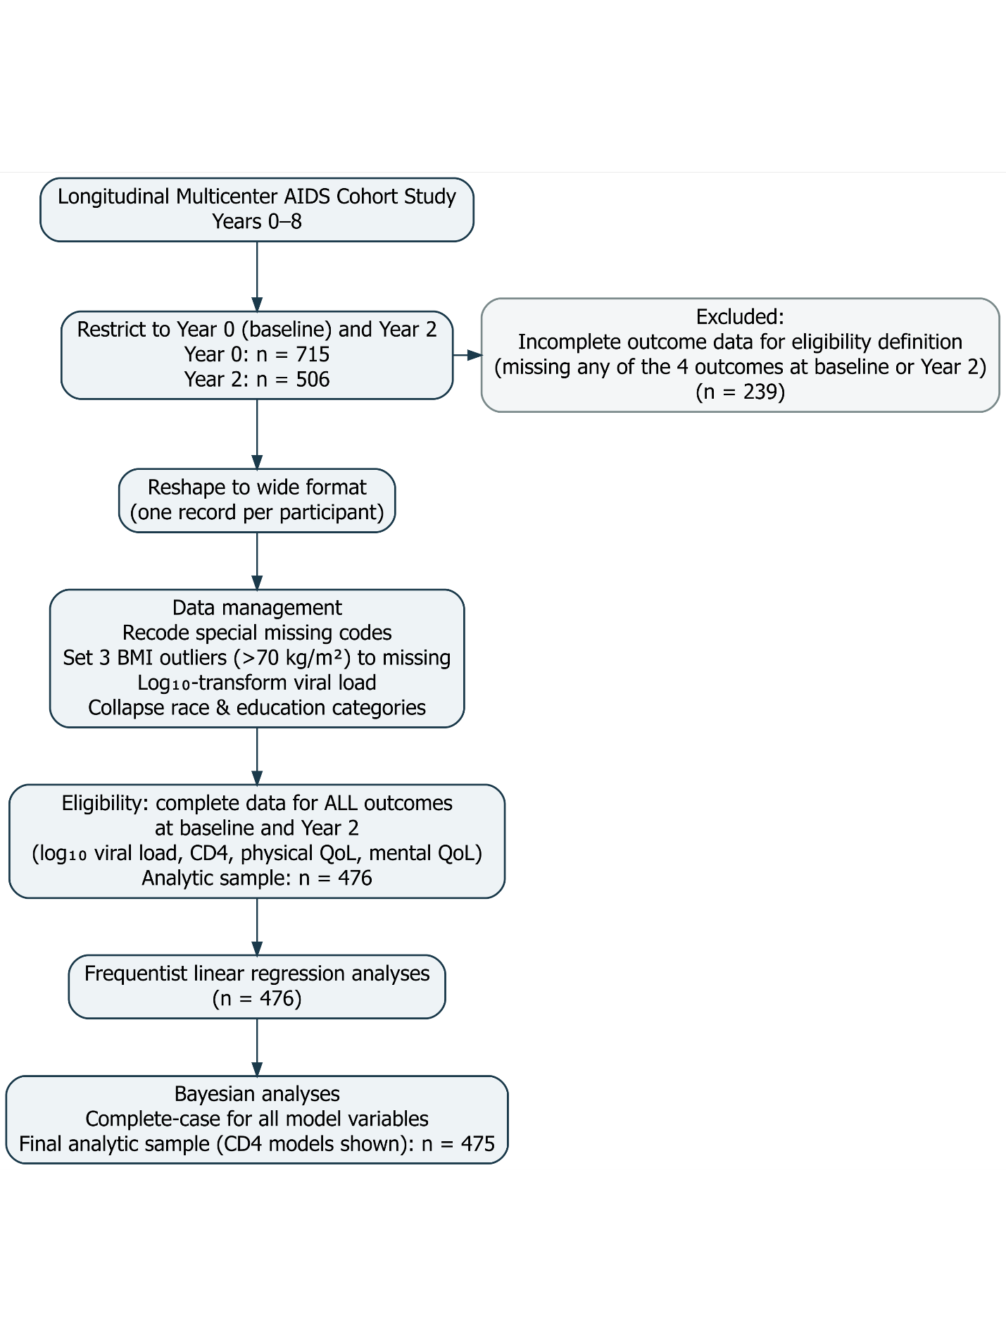

**Figure A2. Distributions of Baseline and Year 2 Outcomes**

Histograms display the distributions of viral load, CD4 cell count, and physical and mental quality-of-life scores at baseline (Year 0) and Year 2. Viral load values are presented on the original scale as recorded in the dataset. Scales differ across panels to reflect the natural range of each outcome. The histograms show marked right-skewness for viral load and approximately symmetric distributions for CD4 count and quality-of-life measures.

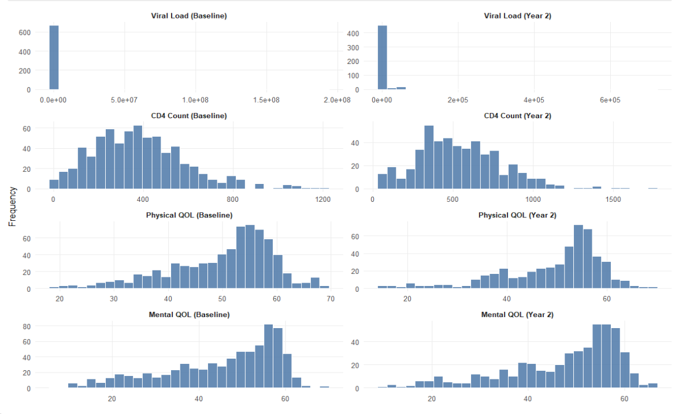

**Figure A3. Distribution of log₁₀ Viral Load at Baseline and Year 2**

Histograms display the distribution of log₁₀-transformed viral load at baseline (Year 0) and Year 2. The log transformation reduces the strong right-skewness observed when viral load is measured on the original scale. Following transformation, the distributions appear approximately symmetric, supporting the use of linear regression models in subsequent analyses.

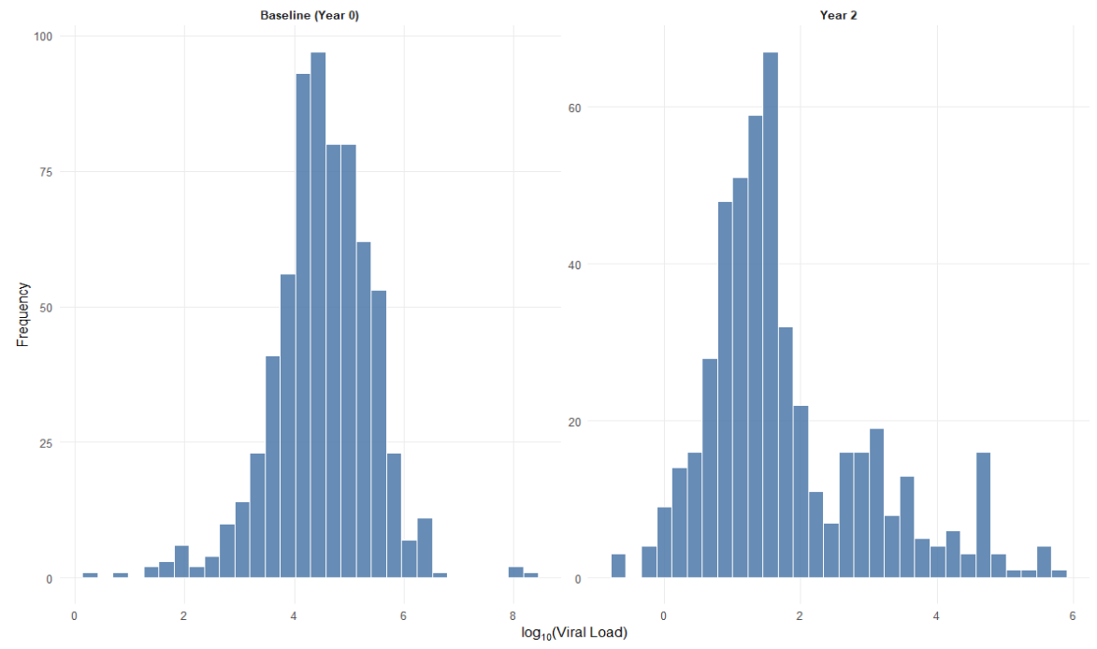

**Figure A4. Year 2 Adherence by Baseline Hard Drug Use Status**

The bar chart shows the number of participants in each Year 2 adherence category, stratified by baseline hard drug use status. Counts are displayed above each bar. Within each adherence category, participants reporting baseline hard drug use are presented first.

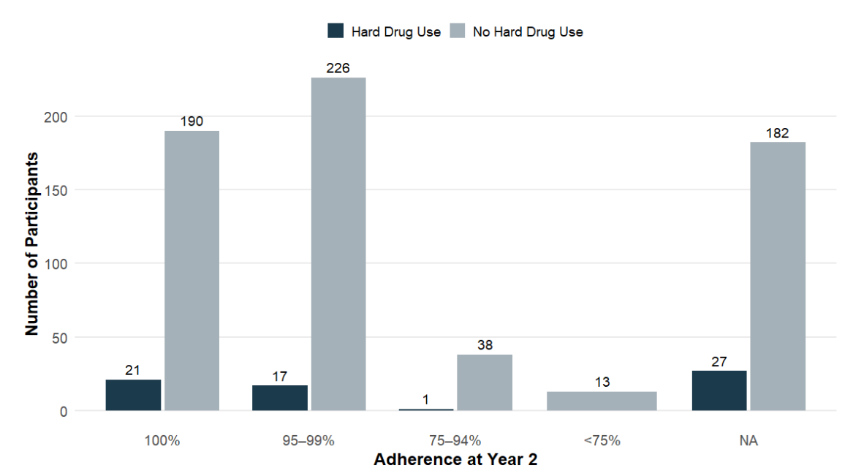

**Figures A5-A13. Diagnostic Tests**

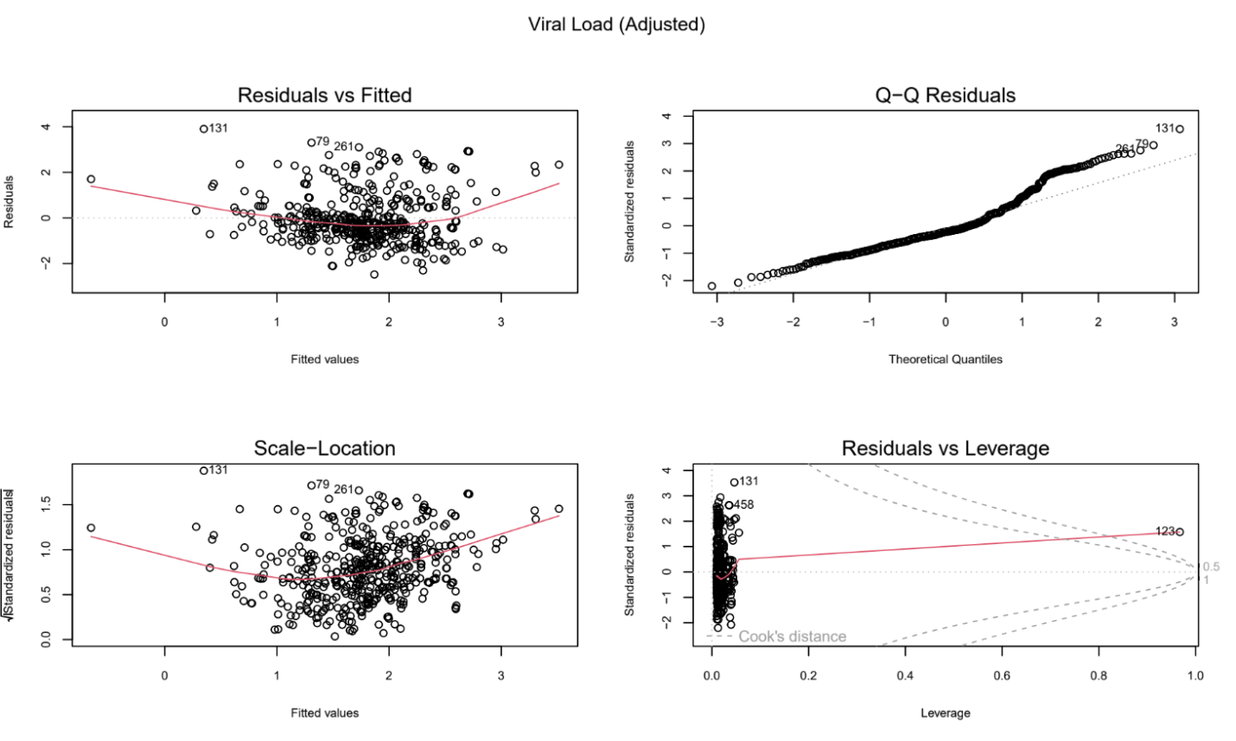Results of diagnostic tests for regression model assumptions are presented below. These include assessments of linearity, normality of residuals, homoscedasticity, and influential observations. Overall, diagnostic plots indicated no substantial violations of model assumptions.

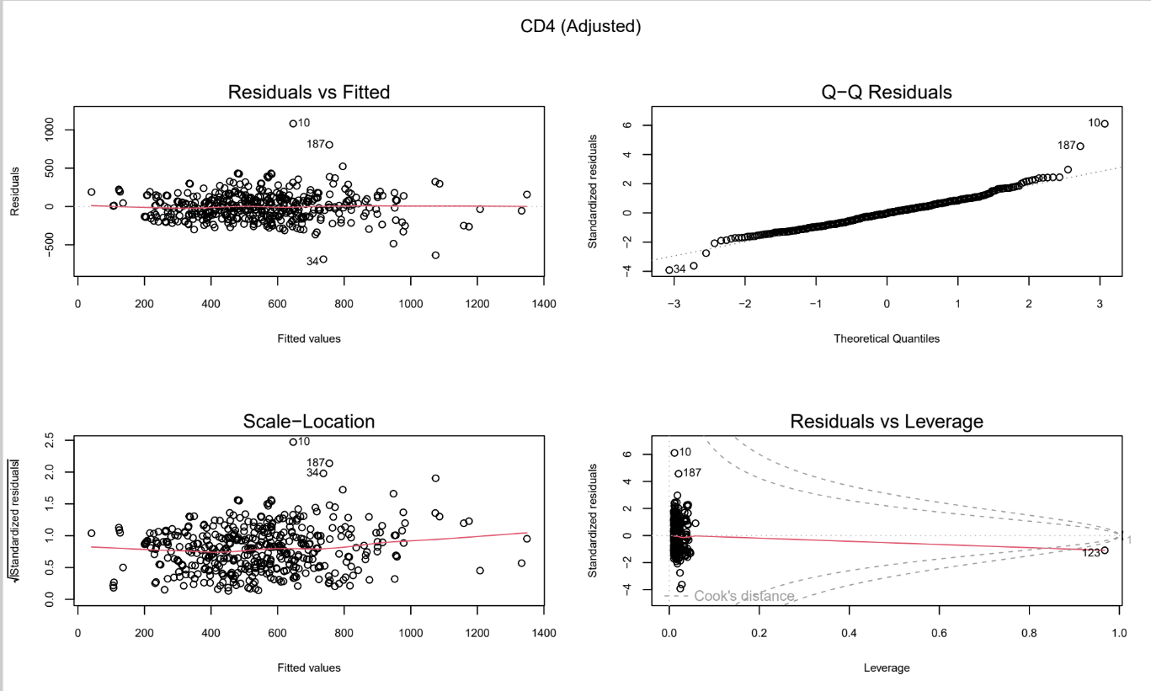

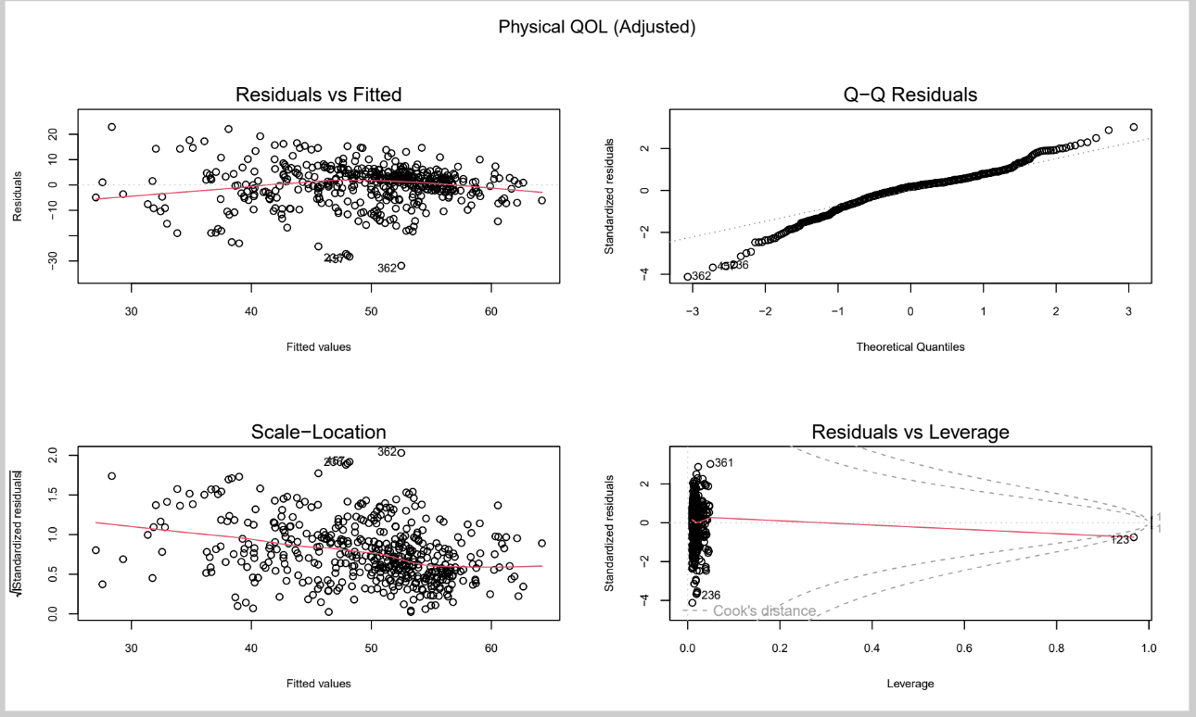

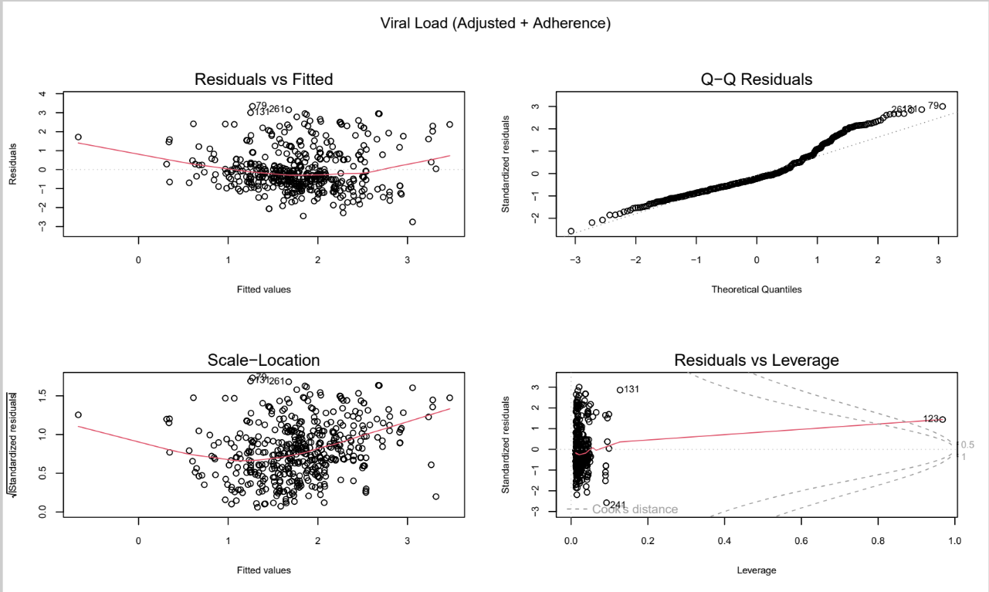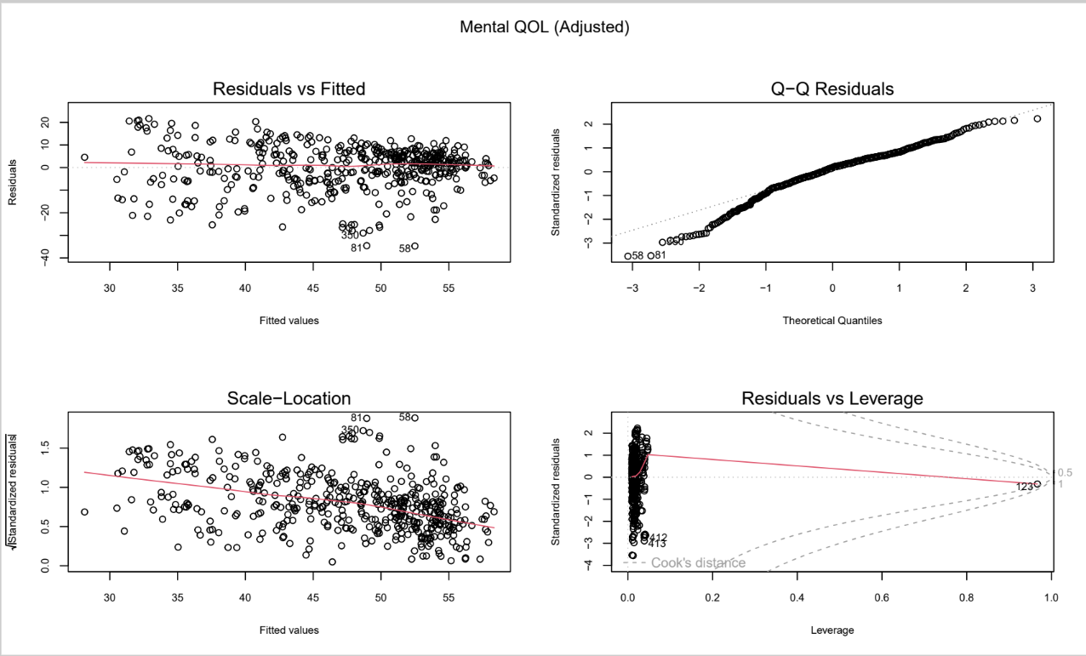

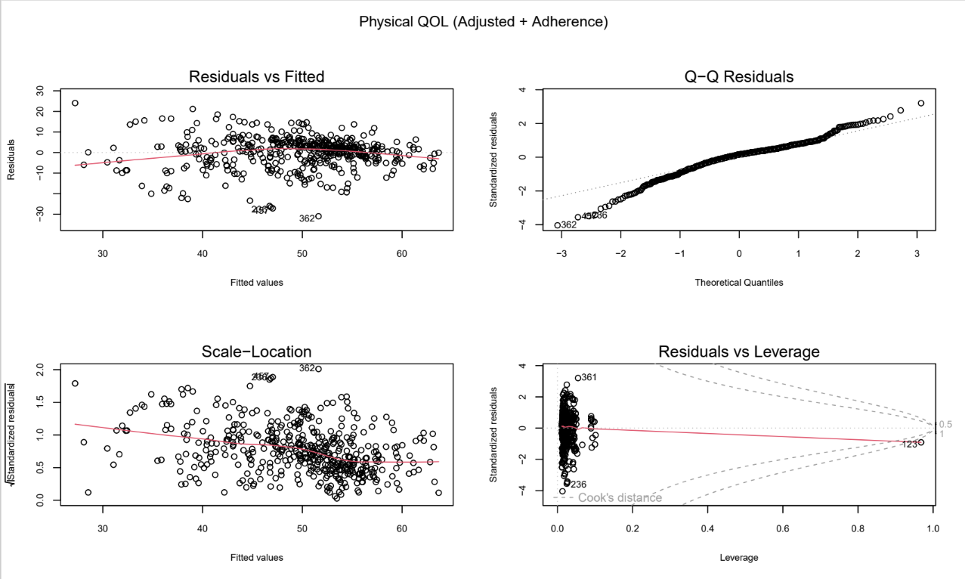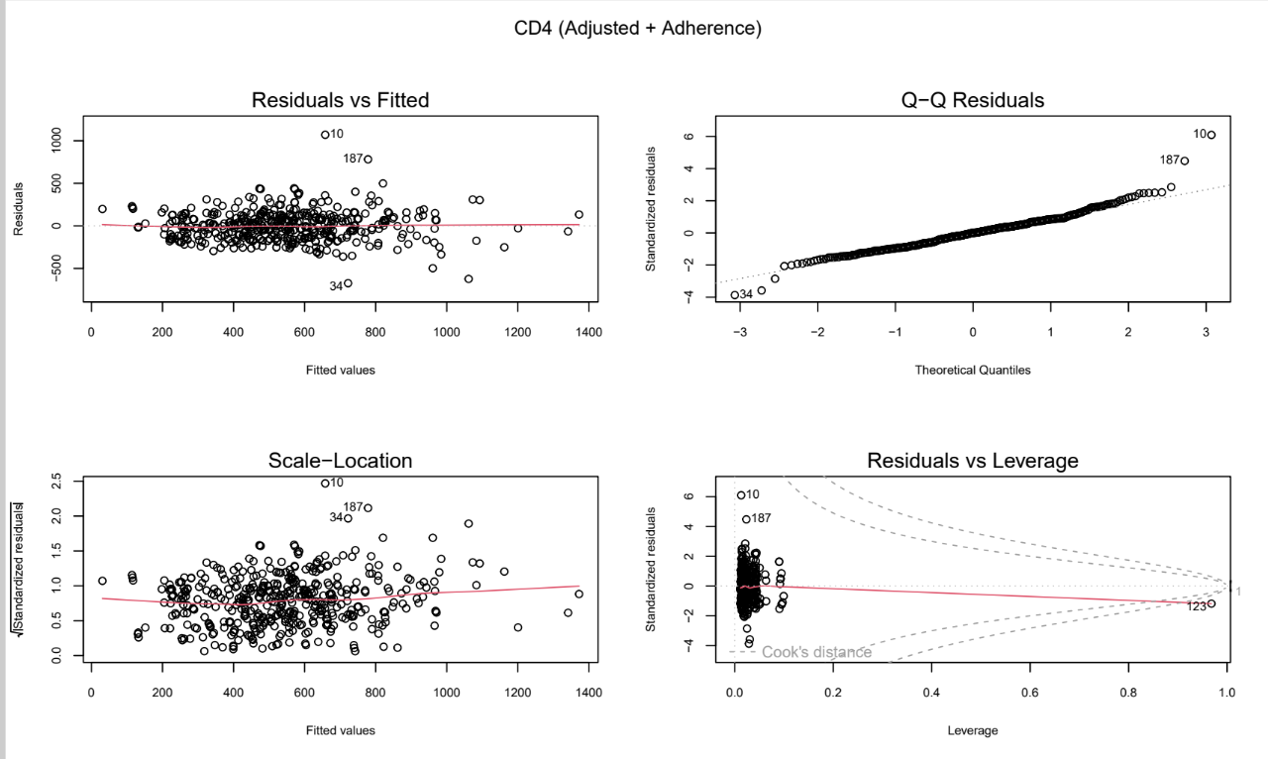

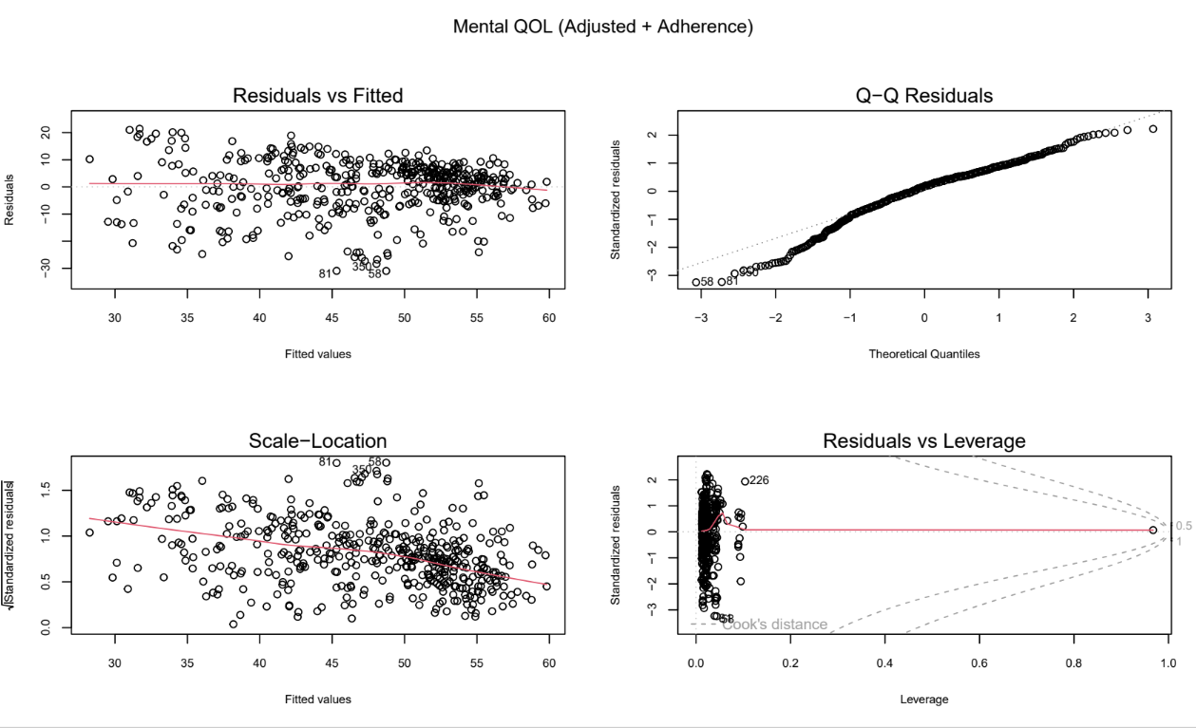

**Model Performance (A14- A38)**

**Viral Load adjusted**

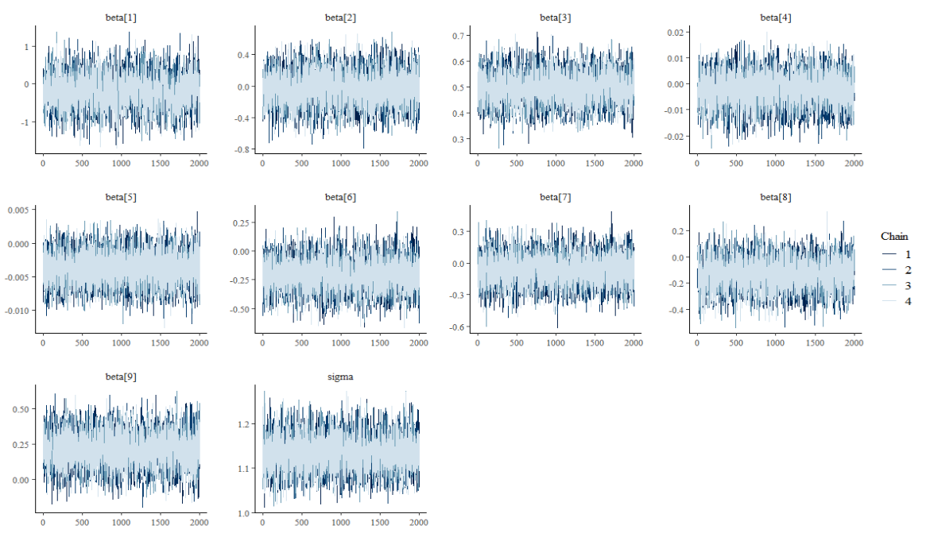

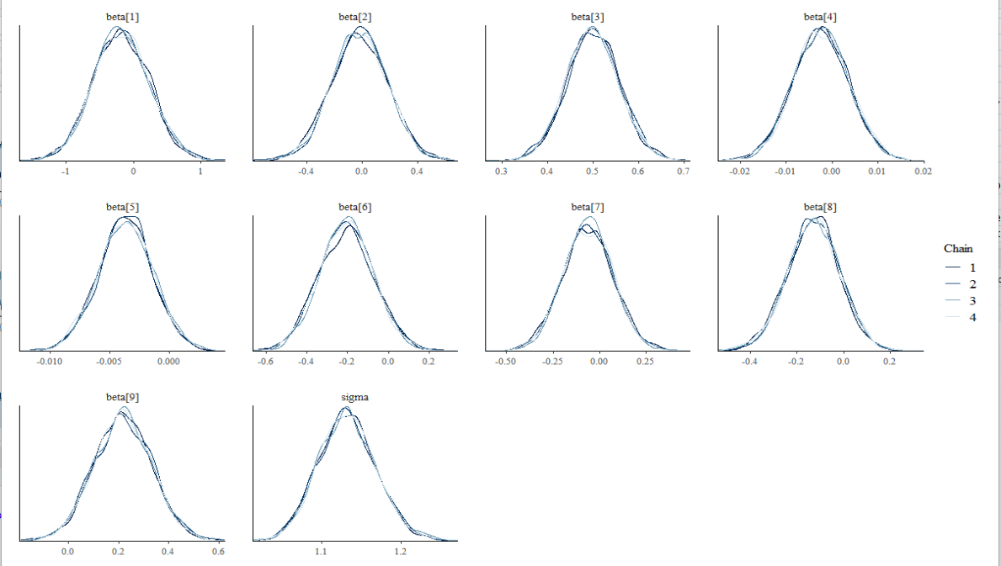

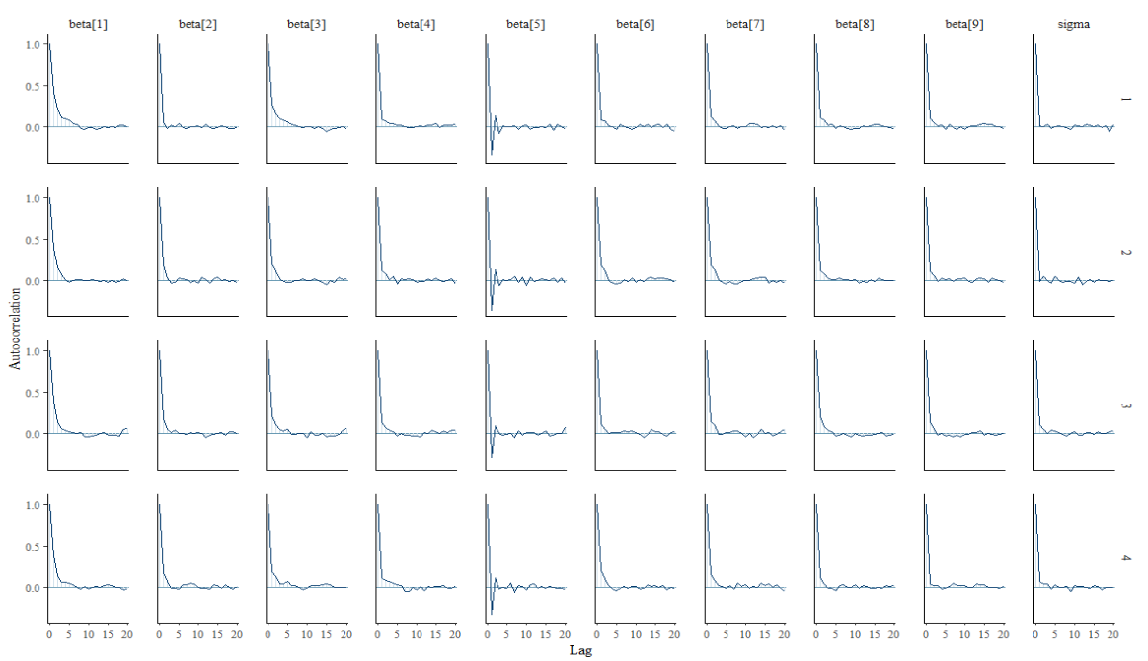

Trace plots demonstrated good mixing across all four chains with no evidence of non-stationarity. Posterior density overlays were nearly identical across chains, and autocorrelation declined rapidly, indicating efficient sampling. Convergence diagnostics were satisfactory (R-hat ≈ 1.00; large effective sample sizes), and predictive performance was modest (elpd_LOO = −738.270, SE = 17.079; p_LOO = 10.637).

**Viral Load and ADH adjusted**

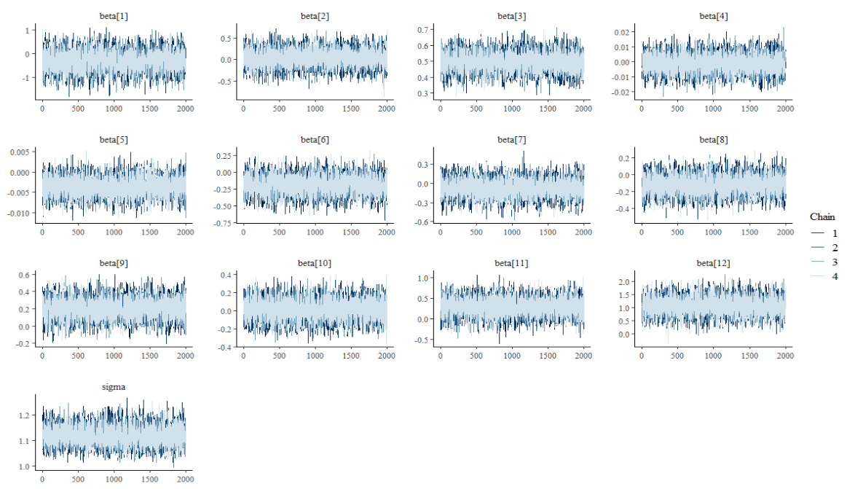

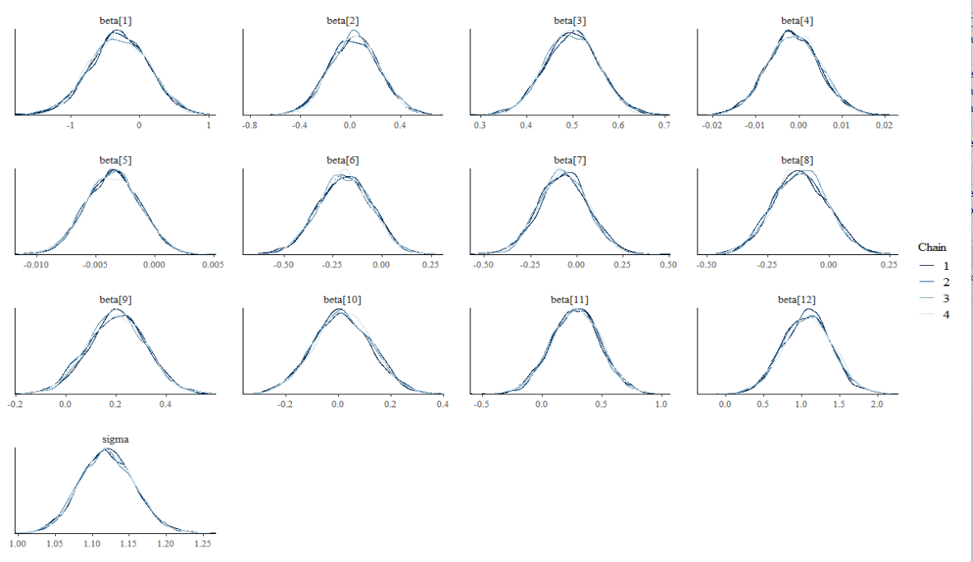

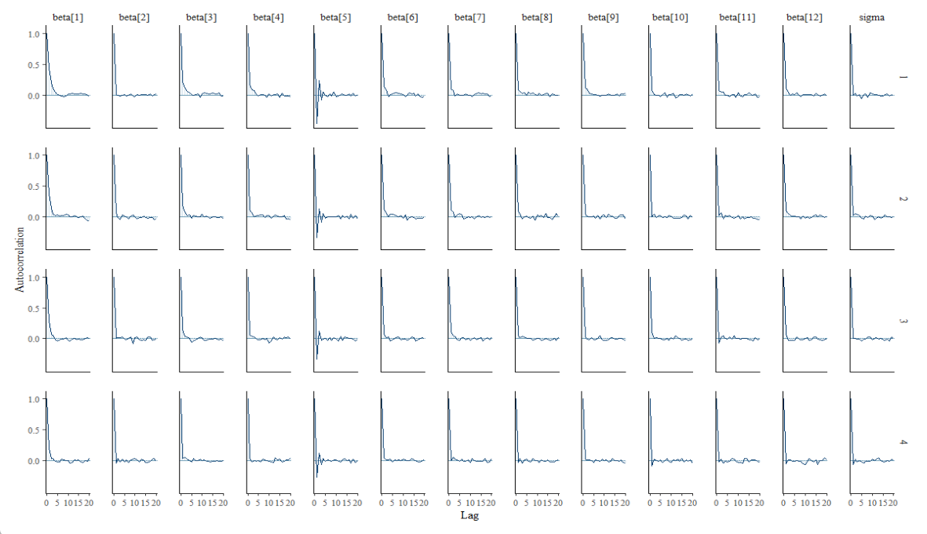

Trace and density plots indicated stable mixing and consistent posterior distributions across chains. Autocorrelation decayed quickly for all parameters, and R-hat values were approximately 1.00 with large effective sample sizes, suggesting reliable convergence. Inclusion of adherence yielded a small improvement in predictive performance (elpd_LOO = −735.640, SE = 16.800; p_LOO = 14.686), although the increase in elpd was small relative to its standard error.

**CD4 Adjusted**

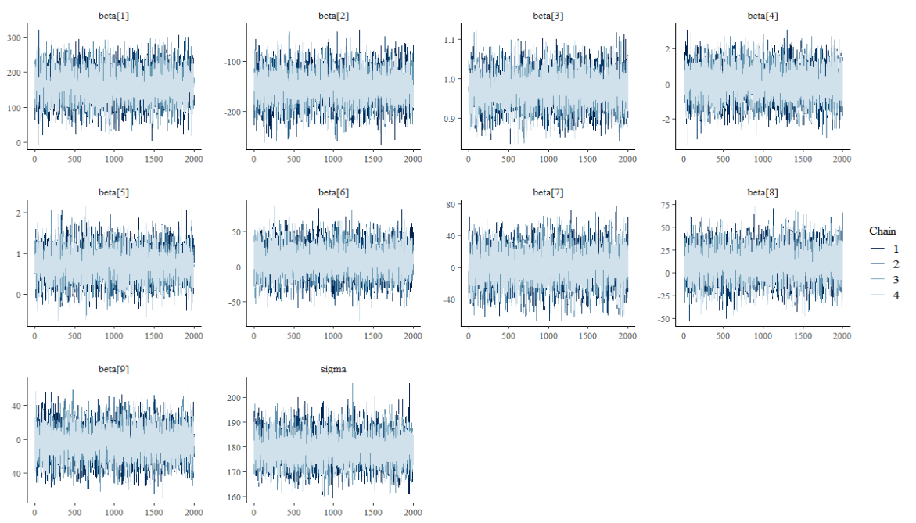

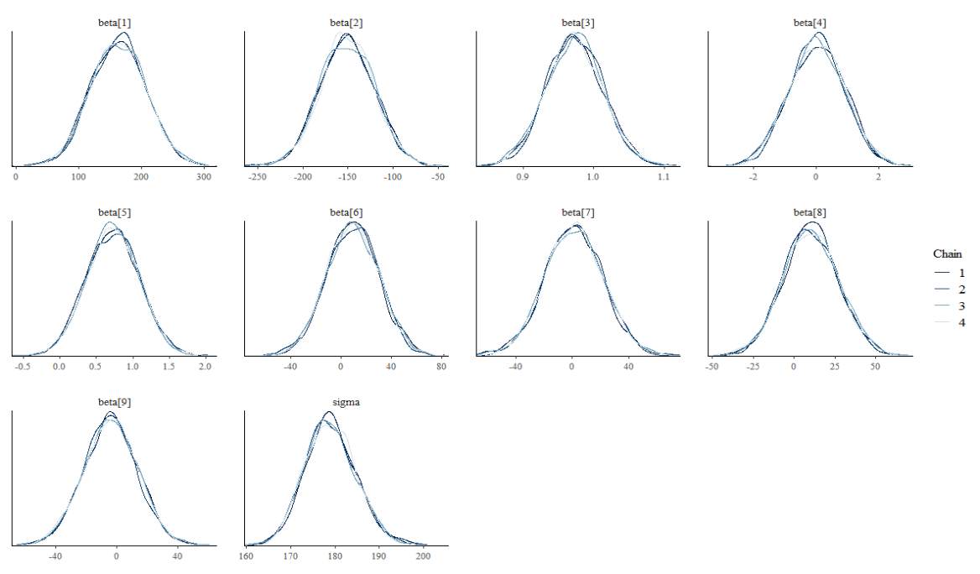

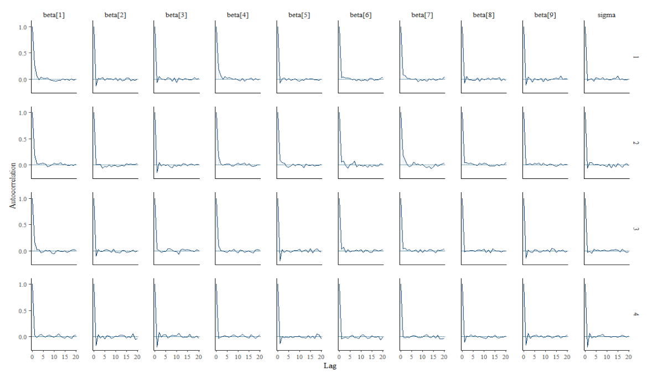

Trace plots showed excellent chain mixing with no signs of non-convergence. Density overlays were highly consistent across chains, and autocorrelation decreased rapidly, reflecting efficient posterior sampling. Predictive performance was strong (elpd_LOO = −3144.188, SE = 26.589; p_LOO = 12.035), indicating good out-of-sample predictive accuracy.

**CD4 Adjusted +ADH**

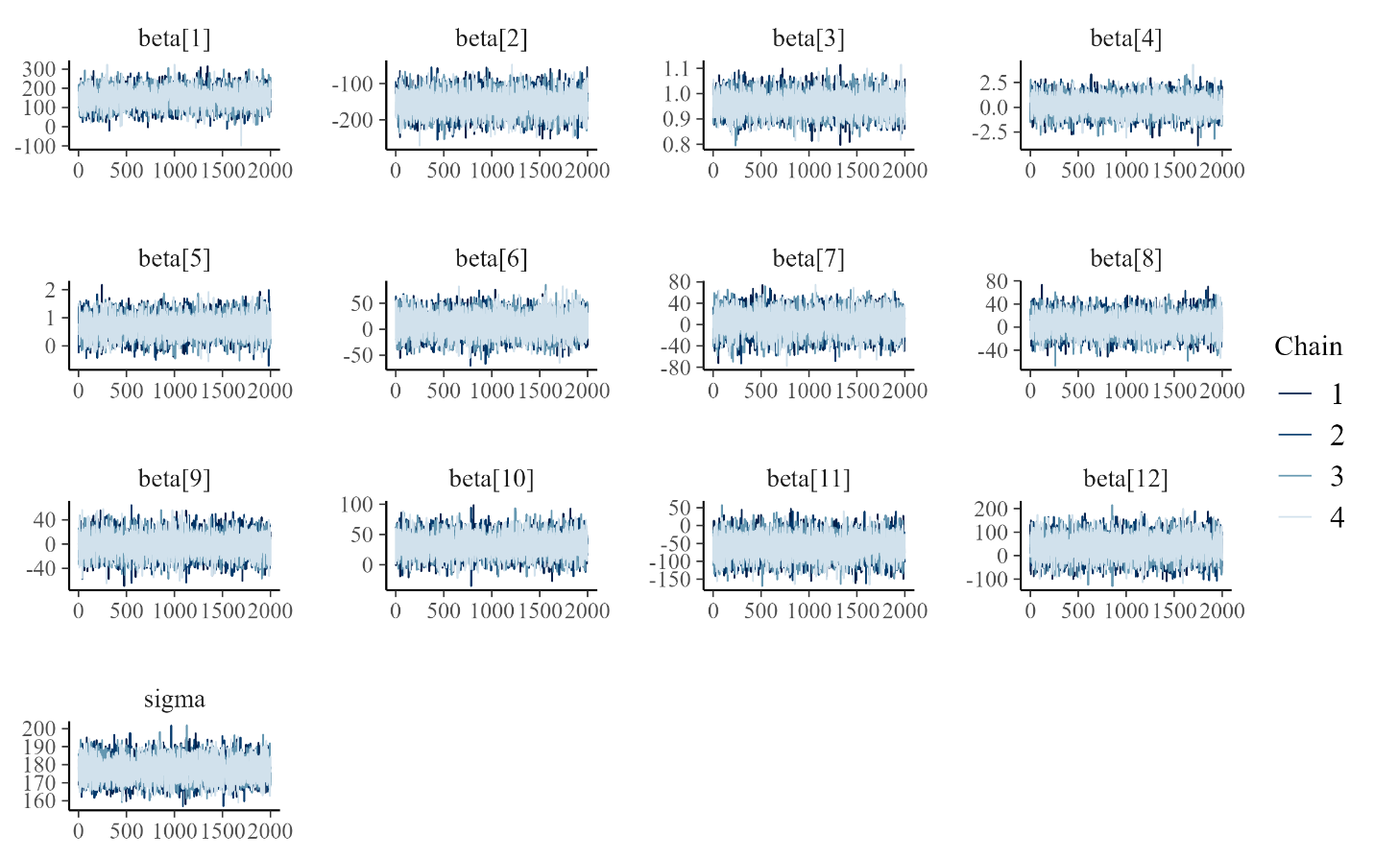

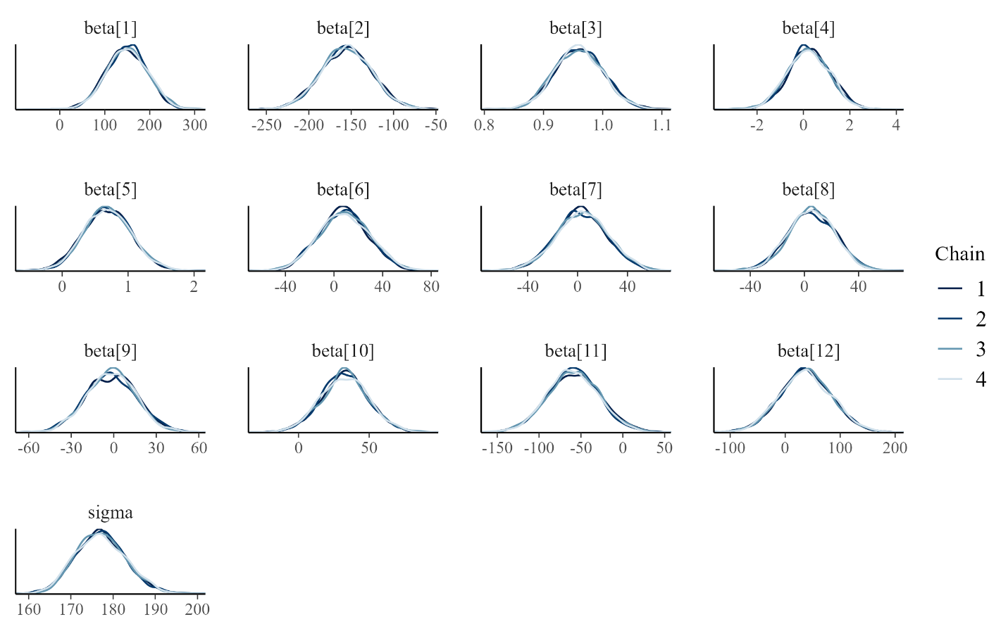

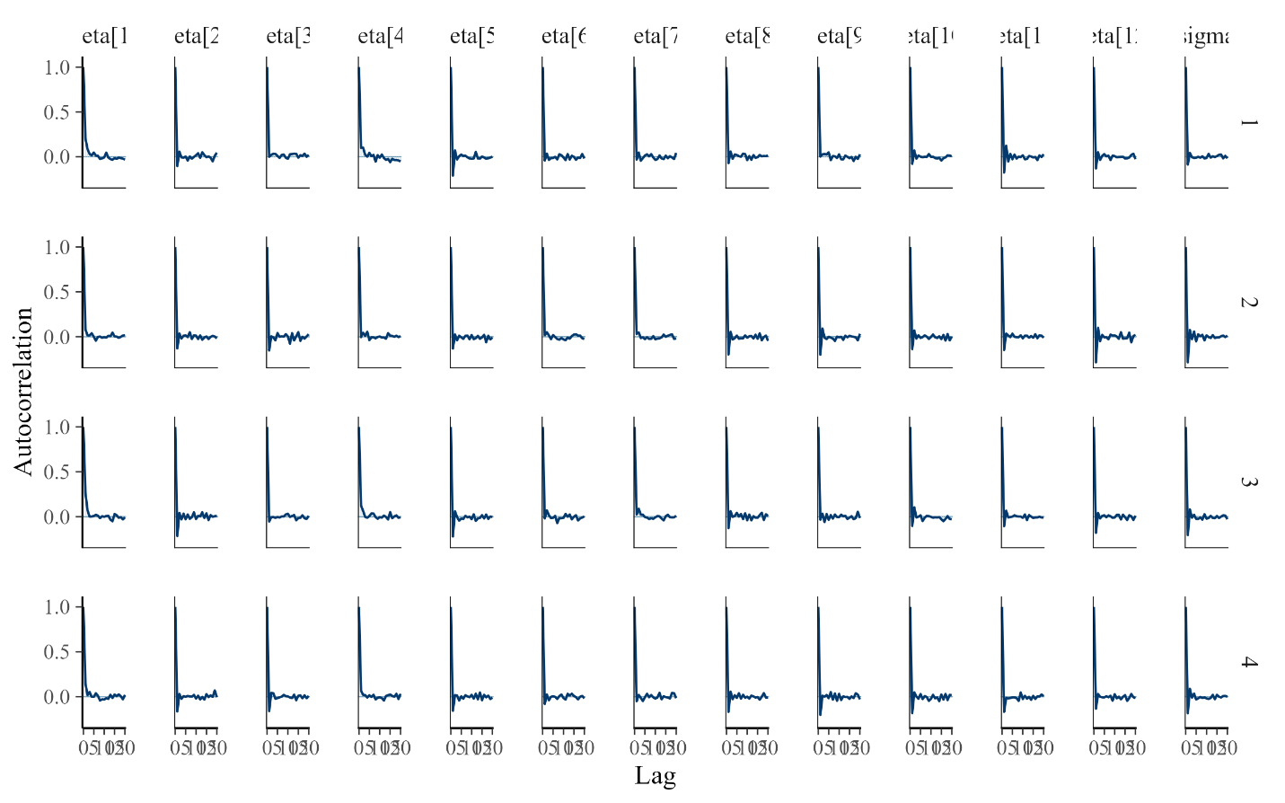

Hamiltonian Monte Carlo diagnostics indicated excellent convergence and sampling efficiency. Trace plots showed strong mixing across chains with no evidence of non-stationarity. Density overlays demonstrated near-perfect chain agreement. Autocorrelation decayed rapidly after lag 1.